Research Article
Paper Title

First Author^{1*}, Second Author², Third Author³

#First-Third Department, First-Third University

Email: ¹first.author@first-third.edu, ²third.author@first-third.edu
Corresponding Email: ³second.author@second.com

Received: 15 July 2023 Accepted: 10 August 2023 Published: 2 September 2023

Abstract: The following document provides authors with formatting instructions for the preparation of manuscripts for publication in the JMET Journal. Refer to the abstract of the article. An abstract is a concise summary of a research article, thesis, review, conference proceeding, or any in-depth analysis of a specific subject or discipline. It is frequently employed to assist the reader in rapidly determining the paper's goal. An abstract is consistently employed at the commencement of a manuscript, serving as the initial entry point for any particular scientific paper or patent application.

Keywords: Approximately five significant words or phrases, separated by commas and arranged in alphabetical order. Documents are retrieved from an information system, such as a search engine or an online journal, using keywords. (Please specify five keywords)

- INTRODUCTION

This document is a template. For questions on paper guidelines, please contact us via e-mail. Identify the constructs of a Journal – Essentially a journal consists of five major sections. The number of pages may vary depending upon the topic of research work but generally comprises up to 5 to 10 pages. These are:
Abstract
Introduction
Research Development
Results or Finding
Conclusions
References

- PAGE LAYOUT

An easy way to comply with EJMCM paper formatting requirements is to use this document as a template and simply type your text into it.
- Page Layout
Your paper must use a page size corresponding to A4 which is 210mm (8.27") wide and 297mm (11.69") long. The margins must be set as follows:
- Top = Bottom= 19mm (0.75")
- Left = Right = 14.32mm (0.56")

- PAGE STYLE

All paragraphs must be indented. All paragraphs must be justified, i.e. both left-justified and right-justified.
- Text Font of Entire Document
The entire document should be in Times New Roman or Times font. 12pt Regular font must be used. Other font types may be used if needed for special purposes.
Recommended font sizes are shown in Table 1.
- Title and Author Details
Title must be in 24 pt Regular font. Author name must be in 12pt Regular font. Author affiliation must be in 12pt Italic. Email address must be in12pt Regular font.

Table 1. Font sizes for papers
Font Size | Appearance (in Time New Roman or Times)
Font Size | Regular | Bold | Italic
8 | table caption (in Small Caps),  figure caption,  reference item |  | reference item (partial)
9 | author email address (in Courier),  cell in a table | abstract body | abstract heading (also in Bold)
10 | level-1 heading (in Small Caps),  paragraph |  | level-2 heading,  level-3 heading,  author affiliation
11 | author name
24 | title

All title and author details must be in single-column format and must be cantered.
Every word in a title must be capitalized except for short minor words such as “a”, “an”, “and”, “as”, “at”, “by”, “for”, “from”, “if”, “in”, “into”, “on”, “or”, “of”, “the”, “to”, “with”.
To avoid confusion, the family name must be written as the last part of each author name (e.g. John A.K. Smith).
Each affiliation must include, at the very least, the name of the company and the name of the country where the author is based (e.g. Causal Productions Pty Ltd, Australia).
Email address is compulsory for the corresponding author.
- Section Headings
No more than 3 levels of headings should be used. All headings must be in 12pt font. Every word in a heading must be capitalized except for short minor words as listed in Section III-B.
- Level-1 Heading: A level-1 heading must be in Small Caps, centered and numbered using uppercase Roman numerals. For example, see heading “III. Page Style” of this document. The two level-1 headings which must not be numbered are “Acknowledgment” and “References”.
- Level-2 Heading: A level-2 heading must be in Italic, left-justified and numbered using an uppercase alphabetic letter followed by a period. For example, see heading “C. Section Headings” above.
- Level-3 Heading: A level-3 heading must be indented, in Italic and numbered with an Arabic numeral followed by a right parenthesis. The level-3 heading must end with a colon. The body of the level-3 section immediately follows the level-3 heading in the same paragraph. For example, this paragraph begins with a level-3 heading.
- Figures and Tables
Figures and tables must be cantered in the column. Large figures and tables may span across both columns. Any table or figure that takes up more than 1 column width must be positioned either at the top or at the bottom of the page.
Graphics may be full colour. All colours will be retained on the CDROM. Graphics must not use stipple fill patterns because they may not be reproduced properly. Please use only SOLID FILLcolours which contrast well both on screen and on a black-and-white hardcopy, as shown in Fig. 1(In bold).

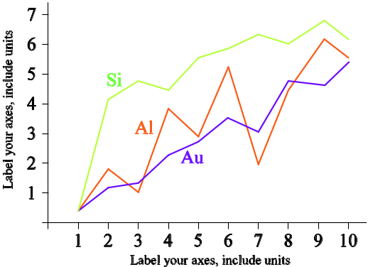
Figure.1 A sample line graph using colours which contrast well both on screen and on a black-and-white hardcopy

Fig. 2 shows an example of a low-resolution image which would not be acceptable, whereas Fig. 3 shows an example of an image with adequate resolution. Check that the resolution is adequate to reveal the important detail in the figure.
Please check all figures in your paper both on screen and on a black-and-white hardcopy. When you check your paper on a black-and-white hardcopy, please ensure that:
- the colours used in each figure contrast well,
- the image used in each figure is clear,
- all text labels in each figure are legible.
- Figure Captions
Figures must be numbered using Arabic numerals. Figure captions must be in 8 pt Regular font. Captions of a single line (e.g. Fig. 2) must be cantered whereas multi-line captions must be justified (e.g. Fig. 1). Captions with figure numbers must be placed after their associated figures, as shown in Fig. 1.
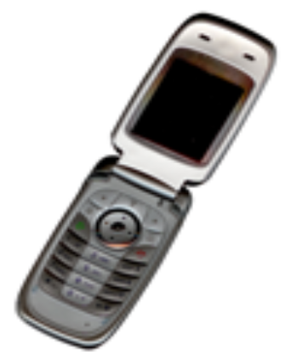
Figure.2 Example of an unacceptable low-resolution image

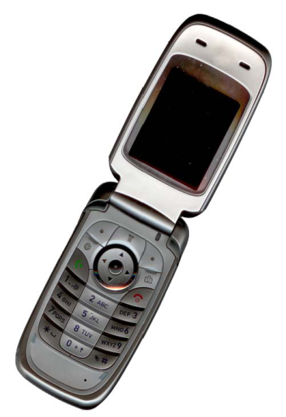
Figure.3 Example of an image with acceptable resolution

- Table Captions
Tables must be numbered using uppercase Roman numerals. Table captions must be centred and in 8 pt Regular font with Small Caps. Every word in a table caption must be capitalized except for short minor words as listed in Section III-B. Captions with table numbers must be placed before their associated tables, as shown in Table 1.
- Page Numbers, Headers and Footers
Page numbers, headers and footers must not be used.
- Links and Bookmarks
All hypertext links and section bookmarks will be removed from papers during the processing of papers for publication. If you need to refer to an Internet email address or URL in your paper, you must type out the address or URL fully in Regular font.
- References
The heading of the References section must not be numbered. All reference items must be in 12pt font. Please use Regular to distinguish different fields as shown in the References section. Number the reference items consecutively in square brackets (e.g. [1]).
When referring to a reference item, please simply use the reference number, as in [2]. Do not use “Ref. [3]” or “Reference [3]” except at the beginning of a sentence, e.g. “Reference [3] shows …”. Multiple references are each numbered with separate brackets (e.g. [2], [3], [4]–[6]).
Examples of reference items of different categories shown in the References section include:
- example of a book in [1]
- example of a book in a series in [2]
- example of a journal article in [3]
- example of a conference paper in [4]
- example of a patent in [5]
- example of a website in [6]
- example of a web page in [7]
- example of a databook as a manual in [8]
- example of a datasheet in [9]
- example of a master’s thesis in [10]
- example of a technical report in [11]
- example of a standard in [12]

- CONCLUSIONS

Reproducing the abstract as the conclusion is not recommended, despite the fact that a conclusion may summarize the primary points of the paper. In conclusion, the significance of the work may be further elaborated upon, or applications and extensions may be suggested.

ACKNOWLEDGMENT
The term "acknowledgement" is preferentially spelled in American English without a "e" following the "g." Even if there are numerous acknowledgements, utilize the singular heading.

CONFLICTS OF INTEREST

- REFERENCES

- S. M. Metev and V. P. Veiko, Laser Assisted Microtechnology, 2nd ed., R. M. Osgood, Jr., Ed. Berlin, Germany: Springer-Verlag, 1998.
- J. Breckling, Ed., The Analysis of Directional Time Series: Applications to Wind Speed and Direction, ser. Lecture Notes in Statistics. Berlin, Germany: Springer, 1989, vol. 61.
- S. Zhang, C. Zhu, J. K. O. Sin, and P. K. T. Mok, “A novel ultrathin elevated channel low-temperature poly-Si TFT,” IEEE Electron Device Lett., vol. 20, pp. 569–571, Nov. 1999.
- M. Wegmuller, J. P. von der Weid, P. Oberson, and N. Gisin, “High resolution fiber distributed measurements with coherent OFDR,” in Proc. ECOC’00, 2000, paper 11.3.4, p. 109.
- R. E. Sorace, V. S. Reinhardt, and S. A. Vaughn, “High-speed digital-to-RF converter,” U.S. Patent 5 668 842, Sept. 16, 1997.
- (2002) The IEEE website. [Online]. Available: http://www.ieee.org/
- M. Shell. (2002) IEEEtran homepage on CTAN. [Online]. Available: http://www.ctan.org/tex-archive/macros/latex/contrib/supported/IEEEtran/
- FLEXChip Signal Processor (MC68175/D), Motorola, 1996.
- “PDCA12-70 data sheet,” Opto Speed SA, Mezzovico, Switzerland.
- A. Karnik, “Performance of TCP congestion control with rate feedback: TCP/ABR and rate adaptive TCP/IP,” M. Eng. thesis, Indian Institute of Science, Bangalore, India, Jan. 1999.
- J. Padhye, V. Firoiu, and D. Towsley, “A stochastic model of TCP Reno congestion avoidance and control,” Univ. of Massachusetts, Amherst, MA, CMPSCI Tech. Rep. 99-02, 1999.
- Wireless LAN Medium Access Control (MAC) and Physical Layer (PHY) Specification, IEEE Std. 802.11, 1997.

Copyright: © 2025 by the authors. It was submitted for open access publication under the terms and conditions of the Creative Commons Attribution-Share Alike 4.0 International License (CC BY SA) license (http://creativecommons.org/licenses/by-sa/4.0/).
